**REVISION - SPEAKING CARDS - UNIT 1-8**

**Card 1:**

**Student A: You are the manager of a software company. Exchange the information with your new employee about some ethical principles.**

|  |  |
| --- | --- |
| * **Student A** | * **Student B** |
| Welcome the new employee | Say greeting |
| Tell the principle 1 (do not read other’s email) | Agree and ask for principle 2 |
| Tell the principle 2 (respect colleagues) | Agree and ask for principle 3 |
| Tell the principle 3 (obey the law) | Ask the manager what will happen if you violate the law. |
| Answer the question (the employee will be fired) | Agree and ask for principle 4 |
| Tell the principle 4 (do not copy others’ work) | Ask the manager what will happen if you duplicate others’ work |
| Answer the question (the employee will be sued) and ask the employee if he/she has other questions. | Say no. |

**Student B: You are a new employee of a software company. Exchange the information with your manager about some ethical principles.**

|  |  |
| --- | --- |
| * **Student A** | * **Student B** |
| Welcome the new employee | Say greeting |
| Tell the principle 1 (do not read other’s email) | Agree and ask for principle 2 |
| Tell the principle 2 (respect colleagues) | Agree and ask for principle 3 |
| Tell the principle 3 (obey the law) | Ask the manager what will happen if you violate the law. |
| Answer the question (the employee will be fired) | Agree and ask for principle 4 |
| Tell the principle 4 (do not copy others’ work) | Ask the manager what will happen if you duplicate others’ work |
| Answer the question (the employee will be sued) and ask the employee if he/she has other questions. | Say no. |

**SAMPLE CONVERSATION:**

*B: Good morning. I am Nam. I am a new employee.*

*A: Good morning. My name is Tuan. How can I help you?*

*B: Can you tell me some ethical principles of our company, please?*

*A: Sure. / Absolutely yes.*

*B: What is the first principle?*

*A: First, do not read other’s email.*

*B: Yes. What about another principle?*

*A: Remember to respect other colleagues.*

*B: Oh, I see. How about the next principle?*

*A: Well, you have to obey the law. This is a very important principle.*

*B: Mm, if I violate the law, what will happen?*

*A: If you violate the law, you will be fired immediately.*

*B: Can you tell me about the 4th principle?*

*A: You are not allowed to copy others’ work.*

*B: What will happen if I duplicate others’ work?*

*A: In this case, you will be sued. Do you have other questions?*

*B: No. Thank you very much for your useful information!*

*A: You’re welcome.*

**Card 2:**

**Student A: Make a conversation with your partner to exchange the steps of developing a successful mobile game**

|  |  |
| --- | --- |
| **Mobile game development** | |
| **First step** | (1) ________________________________________________ |
| **Second step** | Tell a story: make a story for your game (answer the questions about hero and villain in the story, their strengths and weaknesses, the reason to fight, how to achieve victory) |
| **Third step** | (3) ________________________________________________ |
| **Fourth step** | Identify the key platforms:  should focus on the OS which your most profitable players will use and prioritize it |
| **Fifth step** | (5) ________________________________________________ |
| **Sixth step** | Decide the monetization strategy: plan your game monetization strategy before starting with the development; have a plan to recover the investment |
| **Seventh step** | (7) ________________________________________________ |
| **Eighth step** | Choose appropriate developers: need experienced developers to transform your idea into a profitable business |

**Student B: Make a conversation with your partner to exchange the steps of developing a successful mobile game**

|  |  |
| --- | --- |
| **Mobile game development** | |
| **First step** | Work on your idea: create something innovative and engaging   * appeal to a mass audience to help you make profits |
| **Second step** | (2) ________________________________________________ |
| **Third step** | Make the game addictive: make it easy and fun with a gradually increasing difficulty level |
| **Fourth step** | (4) ________________________________________________ |
| **Fifth step** | Create a stunning design: simple as a flat design or a comic style with a 3D layout |
| **Sixth step** | (6) ________________________________________________ |
| **Seventh step** | Decide upon the technology: decide the main design tools to use and the type of game you need to develop |
| **Eighth step** | (8) ________________________________________________ |

***SAMPLE CONVERSATION*:**

***A: Hello, do you know how to develop a successful mobile game? Can we share some information about it?***

***B: Of course.***

***A: What do you do in the first step?***

***B: We should….***

|  |  |
| --- | --- |
| **Student A** | **Student B** |
| 1. What should you do in the first step? | You work on your idea. You should create something innovative and engaging, which appeals to a mass audience to help you make profits |
| We tell a story. You make a story for your game. You can answer following questions:  - Who are hero and villain in the story?  - What are their strengths and weaknesses?  - Why do they fight each other?  - How does the hero achieve victory? | 2. What about the second step? |
| 3. What will you do in the third step? | You will make the game addictive. You should make it easy and fun with a gradually increasing difficulty level. |
| Identify the key platforms. You should focus on the OS which your most profitable players will use and prioritize it. | 4. How about the fourth step? |
| 5. What will you do in the fifth step? | You will create a stunning design. The design should be as simple as a flat design or a comic style with a 3D layout |
| You need to decide the monetization strategy. Please plan your game monetization strategy before starting with the development and have a plan to recover the investment. | 6. What about the sixth step? |
| 7. What will you do in the seventh step? | We will decide upon the technology, Also, you decide the main design tools to use and the type of game you need to develop. |
| Choose appropriate developers. You need experienced developers to transform your idea into a profitable business. | 8. How about the eighth step? |

**Card 3:**

**Student A:** You are an IT expert. A trainee in your computer wants you to explain to him/her about computer maintenance. Make conversation based on the given information in the card below.

|  |  |  |
| --- | --- | --- |
| **Component** | **Maintenance** | **How often** |
| Inside the case | - Make sure air vents are clear  - Use compressed air to blow the dust out of the case, or use a vacuum to clean vents, power supply, and fan  - Ensure that chips and expansion cards are firmly seated | Yearly |
| CMOS setup | - Keep a backup record of CMOS setup | Whenever changes are made |
| Hard drive | - Perform regular backups  - Automatically execute a virus scan program at startup  - Update antivirus software signature files  - Defragment the drive  - Do not allow smoking around the PC  - Place the PC where it will not be jarred, kicked, or bumped | At least weekly  Daily  At least weekly  Monthly  Always  Always |
| Keyboard | - Keep the keyboard clean  - Keep the keyboard away from liquids | Monthly  Always |
| Mouse | - Clean the mouse rollers and ball | Monthly |
| Monitor | - Clean the screen with a soft cloth  - Make sure air vents are clear | At least monthly  Always |
| Software | - Make a backup copy of installation CDs.  - Regularly run Disk Cleanup to delete unneeded files | As allowed by EULA  At least monthly |

**Student B:** You are a trainee in ABC company. You want to understand about computer maintenance so you ask an IT expert to help you. Make conversation based on the given information below.

**Information needed to ask:**

* Name of components needed to be maintained
* Tips to maintain the CMOS setup
* Tips to maintain the software
* Maintenance activities needed to be done monthly
* Maintenance activities needed to be done yearly

**SAMPLE CONVERSATION:**

B: Good morning, sir. I’m A, a trainee in ABC company. Can you share me some tips to maintain a computer?

A: Yes, of course.

B: So what components should be maintained?

A: Well, we must maintain most of components such as hard drive, keyboard, mouse, monitor, software, components inside the case, CMOS setup… to make sure that the whole computer runs well.

B: Can you tell me what should be done to maintain the CMOS setup?

A: Remember to keep a backup record of CMOS setup whenever changes are made.

B: So what should be done to maintain the software?

A: First, you should make a backup copy of installation CDs as allowed by EULA. Second, regularly run Disk Cleanup to delete unneeded files at least once per month.

B: What maintenance activities are needed to be done monthly?

A: You should defragment the hard drive every month to make your computer operate smoothly. In addition, we need to keep the keboard clean and clean the mouse rollers and ball everymonth. It’s also necessary to clean the screen with a soft cloth at least once a month.

B: Well, that’s such useful information. Thank you for spending time with me.

A: You’re welcome.

**Card 4:**

*- Make a conversation to ask and give opinions and recommendation on a new IT product that is going to be launched next year based on the given information in the card below*

|  |  |
| --- | --- |
| ***Student A: Leader*** | ***Student B: Tester*** |
| *1.*  *Greeting.*  *Say the purpose of the meeting (collect opinions/ review of this product, then improve its quality), and ask the tester to give the product review* | *2.*  *Greeting.*  *Say you are glad to give your review on the product.* |
| *3. Ask for his/her opinions on its features (*design, color, size, shape, durability, image quality, battery life, etc.) | *4. Respond to the questions* |
| *5. Ask about the pros and cons over other devices* | *6. Make comparison with other devices which has the same price* |
| *7. Ask about recommendation* | *8. Give some recommendations* |
| *9. Say thanks* |  |

**Sample conversation:**

*A = testing team leader, B = product tester*

***A:*** *Hello. How are you?*

***B:*** *I’m great! Thanks! And you?*

***A:*** *I’m fine, thanks. Have you tested the new product?*

***B****: Yes, I have just tested it this morning.*

***A****: I’d like to ask for your opinions about it to improve its quality.*

***B****: Sure!*

***A****: What do you think about its design?*

***B****: In my opinion, the design of the device is based on a combination of toughened glass and monolithic metal frame. I think it’s durable however, it is only available in black colour.*

***A****: Ok, so do you suggest to have more colour for the device?*

***B****: Yes, if it has more colours, there will be more options for customers.*

***A****: How about the camera?*

***B****: In my point of view, its camera is not as good as those of other phones. It is quite hard to open the camera, I often have to open twice when I want to take photos and the image quality is also not as good as Samsung’s ones.*

***A****: Ok, I got it, maybe we will have to discuss this problem with our team. What do you think about the pros and cons of our device over other devices?*

***B****: About the pros, the touchscreen is smooth, sharp and speedy, the fingerprint sensor is speedy and responsive. The design is simple but impressive.*

***A:*** *Ok, and what about the cons?*

***B:*** *In comparison with other phones at the same price, the camera seems to be the weakness. Its image quality when taking photos in low light conditions isn’t good.*

***A:*** *Thank you very much for your information. We should discuss these problems with our team.*

***B:*** *You’re welcome.*

**Card 5:**

**Asking for information**

|  |  |
| --- | --- |
| **A: Technician** | **B: Customer** |
| - Greet the customer  - Identify yourself | Greet the technician  - Identify yourself  - Ask for information about **Half-life: Alyx** |
| Ask B what he/she wants to know | Ask for release date |
| Respond: **March 2020 (on Windows)** | Ask A if you need special hardware |
| Respond: **PC-compatible VR headset (e.g.: Valve Index or Oculus Rift)** | Ask A about system requirements |
| State minimum requirements:  - Processor: **Core i5-7500**  **- Ram: 12 GB**  - Graphic card: **Nvidia GTX 1060** | Thank A |
| - Offers additional help | Decline. |
| - End the conversation | Say goodbye |

**Suggested answers:**

**A: Hello, customer support, how may I help you?**

**B: Yes, I’d like some information about the game Half-life: Alyx.**

**A: Of course, what would you like to know?**

**B: First of all, when will it be released?**

**A: It is scheduled for release on Windows in March 2020.**

**B: Do I need any special hardware to play this game.**

**A: I’m afraid you do. You need a PC-compatible VR headset like a Valve Index or Oculus Rift.**

**B: I see. Can you tell me about system requirements I need to play it?**

**A: Well as for processor and memory, you will need at least Core i5-7500 and 12GB of RAM. As for graphic card, you need a Nvidia GTX 1060.**

**B: Thanks for your information.**

**A: Glad to be of help.**

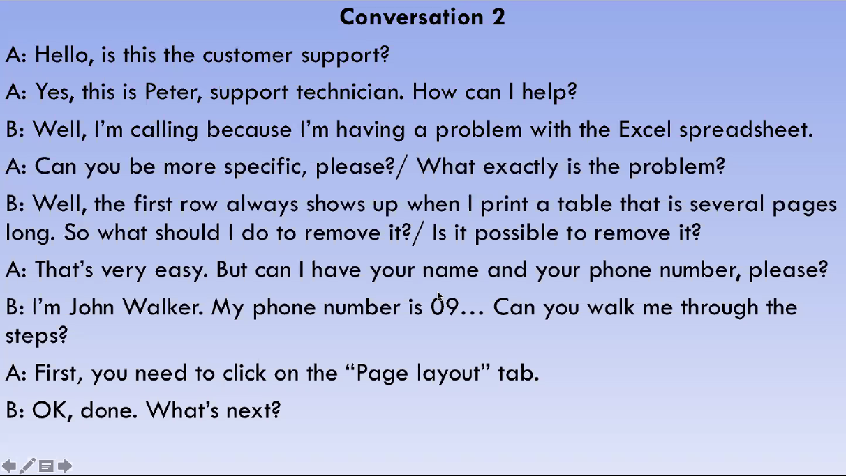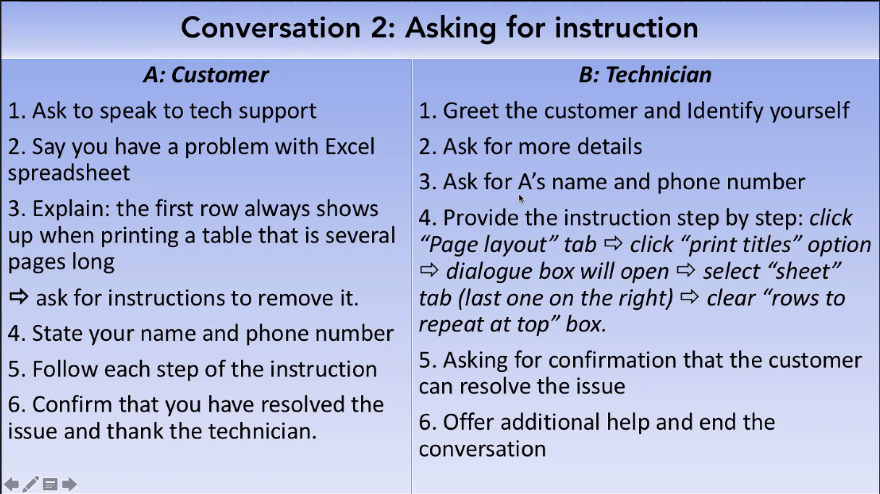

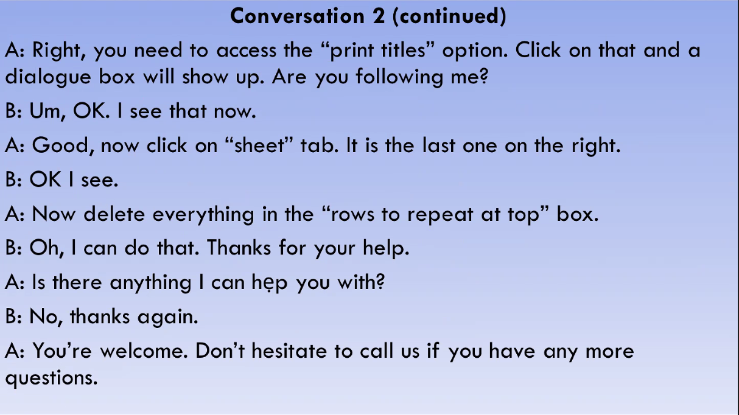

**Card 6:**

***Handling an issue while a customer is on hold***

|  |  |
| --- | --- |
| **A: Technician** | **B: Customer** |
| - Greet the customer  - Identify yourself | Complain about a problem with website |
| Ask for B’s name and phone number | State your name and phone number |
| Ask for details of problem | Explain your problem: can’t log in |
| Ask for computer brand and OS | - Computer brand: Dell Vostro 3250  - OS: Windows 8 |
| Ask for browser and IP address | - Browser: Google Chrome  - IP address: 168.235.1.1 |
| - Summarize the details  - Ask B if you have the correct information | Confirm the details |
| - Apologize  - Empathize  - Reassure  - Ask if B wants to wait or wants a callback | Say you’ll wait |
| - Say you are working on the issue  - Ask B to try logging in again | Say you’ve logged in successfully  Thank A |
| Offer additional help | Decline |
| End the conversation | Say goodbye |

**Suggested answer:**

**T: Apex Technical support. Tom speaking. How may I help you?**

**C: Oh, good. I’m afraid I have a complaint to make. I have a problem with your website.**

**T: First, let me just get your name and phone number in case we get disconnected.**

**C: My name is Melinda and my phone number is 555 232.**

**T: And what kind of problem do you have with our website?**

**C: I can’t log in to my account.**

**T: OK then. I need to know your computer brand and the OS you are using.**

**C: I have a Dell Vostro 2350 and I’m using Windows 8.**

**T:** OK, can you tell me what kind of browser you are using and your IP address?

C: I’m using Google Chrome and my IP address is 168.235.1.1.

T: Now let me repeat back to you to check if I got everything down correctly. You can’t log in to your account on your Dell Vostro 2350 computer with Windows 8. You are using Google Chrome and your IP address is 168.235.1.1. Is that correct?

C: Yes, that’s right.

T: Let me start by saying that I’m sorry this happened to you. I’m sure I’d be upset too if I were you. I’m going to do all that I can to help you. Do you want to stay on the line while I’m fixing it or would you like me to call back?

C: I’ll wait please.

T: OK I’m working on the issue. Now can you try logging in again?

**C: Oh, I can log in now. Thank you very much.**

**T: I’m glad to be of help. Is there anything else I can help you with?**

**C: No, that’s all for now. Goodbye.**

**T: Goodbye. And please call again if you have further problems.**

**Card 7*: Arranging on-site support***

|  |  |
| --- | --- |
| **A: Customer** | **B: Technician** |
| Ask for technical support | - Greet the customer  - Identify yourself |
| Ask for an update on a previously reported problem (related to phone app) | Ask for ticket number |
| Ticket number: 823431 | Ask A to confirm the details  - Name: Mark Grey  - Address: 23, Park Hill  - Phone: Samsung 7 plus  - OS: Android  - Issue: unable to make airplane ticket booking |
| - Say the details are correct  - Ask B about the progress of handling the issue | Report:  - Check connection to booking website  - Check browser version  ⇨ Find no issue |
| - Express anger (you called 6 hours ago)  - Say you need to travel tomorrow | - Apologize  - Empathize  - Reassure  ⇨ Say: on-site technician will visit in next 2 hours |
| - Say you’ll wait | - Promise: you’ll stay involved  - Offer additional help |
| Decline and end the conversation | Thank the customer and say goodbye |

**Suggested answer:**

**C: Hello, is this the number of the technical support department?**

**T: Yes, hello, this is John, your service agent from Apex. Can I help you?**

**C: I’d like an update on my problem with one of your applications.**

**T: Can you tell me your ticket number please?**

**C: Let me check:** 823431

T: OK, let me read back to you your details first: you are Mr. Mark Grey, address: 23 Park Hill. You are using Samsung 7 plus with Android. And you were unable to make airplane ticket booking through our booking application. Is that correct?

C: Yes that’s right. I’d like to know what you have done so far about my issue.

T: Well, we have checked your connection to the website and find no issue, your browser version is also current.

C: This is getting ridiculous. I called your company 6 hours ago. I will need to travel tomorrow. What are you going to do about this?

T: First, let me start by saying that I’m sorry this happened to you. I’m sure I’d be upset too if I were you. I’m going to do all that I can to help you. In fact, I already escalated your ticket to an on-site technician. He’s going to visit your house in the next 2 hours.

**C: OK, I’ll wait**

**T: Please know that I’m going to personally monitor your issue and make sure that it’s taken care of. Is there anything else I can help you with?**

**C: No, thanks. Goodbye**

**T: Thank you for bringing this to our attention. Goodbye.**

**Card 8:**

**Card A: Student A exchanges with student B about Mark’s personal information (major, qualifications, year of graduation, work experience, strengths), then ask him/her about suitable options for Mark’s future career.**

|  |  |  |
| --- | --- | --- |
|  | **Mark** | **Brian** |
| **Major** | 1. _________________ | Network security |
| **Qualifications/ Degrees** | 2. _________________ | Diploma in Computer Science, London University |
| **Year of graduation** | 3. _________________ | 2020 |
| **Work experience** | 4. ________________ | - An intern at UK Technology Consultancy last summer holiday  - A technical support collaborator for Dell since March, 2019 |
| **Strengths** | 5. _________________ | - A top troubleshooter in Vietnam  - Critical thinking |
| **Weaknesses** | - Work overtime  -Sometimes hard to communicate with her | - Hot-tempered, sometimes late for work |
| **Job options** | 6. ________________ | Computer security specialist |

**Card B: Student B exchanges with student A about Brian’s personal information (major, qualifications, year of graduation, work experience, strengths), then ask him/her about suitable options for Brian’s future career.**

|  |  |  |
| --- | --- | --- |
|  | **Mark** | **Brian** |
| **Major** | Programming | 1. ________________ |
| **Qualifications/ Degrees** | Bachelor's degree in programming, Hanoi University of Science and Technology | 2. ________________ |
| **Year of graduation** | 2021 | 3. ________________ |
| **Work experience** | - Work as a part-time software engineer for FPT Soft since October, 2019  - Write over 10 programs in C and Visual Basic  - Take a three-month course game development in India at the end of this year | 4. ________________ |
| **Strengths** | - Skilled at using many programming languages such as COBOL, BASIC, C, JavaScript and so on.  - Good at languages: English, French.  - Responsibility for the work  - Creative | 5. ________________ |
| **Weaknesses** | - Work overtime  -Sometimes hard to communicate with her | - Hot-tempered, sometimes late for work |
| **Job options** | Programmer | 6. __________________ |

**Suggested answer:**

|  |  |
| --- | --- |
| **Student A** | **Student B** |
| 1. What’s Mark’s major?  2. What degrees will he get from his University?  3. When is he going to graduate from the university?  4. Has he had any work experience?  5. What are his strengths?  6. What job will suit her? | 1. It’s programming.  2. He will get a Bachelor's degree in programming from Hanoi University of Science and Technology  3. By 2021.  4. Yes. He has worked as a part-time software engineer for FPT Soft since October, 2019. He also has written over 10 programs in C and Visual Basic. Besides, he is going to take a three-month course game development in India at the end of this year.  5. He is not only skilled at using many programming languages such as COBOL, BASIC, C, JavaScript and so on, but also good at languages. She can speak English and French very well. In addition, he’s creative and has responsibility for the work.  6. I think the position of a programmer will suit her best. |
| 1. It’s network security.  2. She will earn a Diploma in Computer Science from London University.  3. By 2020.  4. He was an intern at UK Technology Consultancy last summer holiday. Moreover, he has been a technical support collaborator for Dell since March, 2019  5. Well. He’s a top troubleshooter in Australia and he is a kind of critical thinking.  6. Well, I think the position of a Computer security specialist will suit her best. | 1. What’s Brian’s major?  2. What degree will she earn from university?  3. When is he going to graduate from the university?  4. What work experience has he had?  5. What are his strengths?  6. What job will suit her best? |

**Card 9:**

**Card A (Student A):** You’ve just graduated from university and want to apply for a job. Make a conversation with a professional (student B) who has more than 5 years of working experience about necessary documents for your application packet.

**Student B**

**Student A**

Greet, say your plan and ask about documents needed when applying a job

Greet, name the needed documents (CV, cover letter, copies of qualifications, a copy of ID, medical report,…)

Respond (CV) and give reasons (show qualifications, work experience, skills, …; show how the applicants handle and process information)

Ask about the most importantdocument

Ask about what to include in a CV

Respond (name and contact details, personal statement, education and qualifications, work experience, hobby & interests (maybe))

Ask about tips to write a perfect CV

Respond (keep it brief, focus on professional experience, use facts and figures, proofread for errors and grammar mistakes)

Ask about the second important document

Respond (cover letter)

Ask if it’s used to explain how candidatesare qualified for job position

Agree, and give reasons (show how a candidate’s work experience & skills meet job requirements, show why a candidate wants to work at the organization)

Say you need to prepare a lot and make great effort to get a good job

End the conversation!

Say you’re willing to help if he/she needs

End the conversation!

**Card B (Student B):** You are an IT professional with more than five years of working experience. A graduate student (student B) is finding a job and want you to give him/her advice on necessary documentsfor his/her application packet. Make a conversation with your partner based on the given information in the card below.

**Student B**

**Student A**

Greet,say your plan and ask about documents needed when applying a job

Greet,name the needed documents (CV, cover letter, copies of qualifications, a copy of ID, medical report,…)

Respond (CV) and give reasons (show qualifications, work experience, skills, …; show how the applicants handle and process information)

Ask about the most important document

Ask about what to include in a CV

Respond (name and contact details, personal statement, education and qualifications, work experience, hobby & interests (maybe))

Ask about tips to write a perfect CV

Respond (keep it brief, focus on professional experience, use facts and figures, proofread for errors and grammar mistakes)

Ask about the second important document

Respond (cover letter)

Ask if it’s used to explain how candidates are qualified for job position

Agree, and give reasons (show how a candidate’s work experience & skills meet job requirements, show why a candidate wants to work at the organization)

Say you need to prepare a lot and make great effort to get a good job

End the conversation!

Say you’re willing to help if he/she needs

End the conversation!

**Suggested answer:**

A:Good morning, sir. I’m a graduate student and want to find a job now. Would you mind giving me some advice on necessary documents for my application packet?

B: Yes, certainly!

A: So what documents do I need to prepare when applying for a job?

B:Well, you need to prepare a CV, a cover letter, copies of qualifications, a copy of ID, medical report and many other ones.

A: What is the most important document in my application packet?

B: It’s CV because it shows all about candidates including qualifications, work experience, skills,…In addition, it also shows how the applicants handle and process information.

A: What information is included in a CV?

B: The details you need to include are your name and contact details, personal statement, education and qualifications, work experience, hobby & interests (maybe).

A: Can you share me some tips to write a perfect CV?

B: Well, to write a great CV, first, you need to keep it brief. Second, focus on professional experience. Third, use facts and figures. And finally, remember to proofread for errors and grammar mistakes before sending your CV to the recruiter.

A: So what is the second important document in my application packet?

B: It’s cover letter.

A: Is it used to explain how candidates are qualified for job position?

B: Exactly. A cover letter shows how a candidate’s work experience & skills meet job requirements and shows why a candidate wants to work at the organization.

B: Well, maybe I need to prepare a lot and make great effort to get a good job.

A: That’s right. I’m willing to help If you need.

A: Thank you very much for sharing time with me.

B: You’re welcome!

**Card 10:**

- Student A plays a role as an interviewer of Samsung, and student B as an interviewee who applies for a job in IT field.

- Make a job interview role play by using given information on the card

|  |  |
| --- | --- |
| **A = Interviewer** | **B = Interviewee** |
| Greet, introduce your name and position | Respond to the interviewer’s greeting |
| Ask the candidate to introduce himself/ herself | Introduce yourself (for example: name, educational background and personalities,…) |
| Ask about his/ her strength/ weakness | Strengths: work under high pressure, master low and high-level programming languages  Weakness: be afraid of speaking in front of public |
| Ask how he/she heard about the position | Say that you read about it on careerlink.vn |
| Ask about his/her working experience | Respond:  - Take a part-time job as a junior programmer when you were a fourth-year student  - Work as a software developer in Y company since you graduated from university |
| Ask about what his/ her job responsibilities in Y company | Respond:  - Meet with customers to analyze their needs  - Develop software applications from start to finish |
| Ask why she/ he wants to leave that job | Give reasons:  - Expect higher income to take better care of family  - Seek for more opportunities to work with foreign people and develop career |
| Ask about his/her salary expectation for this new position | Respond:  - Salary expectation: be in line with technical skills and qualifications. |
| Ask about his/her future plan in two coming years | Respond: be a senior software developer |
| Ask if she/ he has any questions | Ask when you get the result of the interview |
| Respond: by the end of the month  End the interview | Say thanks and good bye |

**Suggested answer:**

**A: Interviewer B: Interviewee**

A: Good morning. I am (A), the Human Resources manager of ABC company. I’ll be interviewing you today. Can you introduce a little bit about yourself?

B: Sure. Nice to meet you. My name is (B). I graduated from Hanoi University of Industry with a degree in Software Engineering. I would describe myself as someone who is an organized person.

A: What is your greatest strength and weakness?

B: Well, I am skilled at working under high pressure and mastering low as well as high-level programming languages. But I’m afraid of speaking in front of public.

A: OK. Another question for you is that how you heard about this position?

B: To be honest, I read about it on careerlink.vn, a career website.

A: What about your working experience?

B: I took a part-time job as a junior programmer when I was the fourth-year students at HaUI. Besides, I have been working as a software developer in Y company since I graduated from university

A: What are your responsibilities in Y company?

B: I am in charge of meeting with customers to analyze their needs and developing software applications from start to finish that allow users to do specific tasks on a computer or another device.

A: Why do you want to leave that job?

B: I expect higher income to take better care of my family. Also, I want to seek for more opportunities to work with foreign people and develop my career.

A: What salary expectation would you like for this new position?

B: I hope that my salary is in line with my qualifications. I expect to be paid about 1,000 USD.

A: What are your future plans in two years? / Where do you see yourself being in two years from now?

B: Well, that’s a very hard question. ….hmmmm…. I’d love to be a senior software developer.

A: That’s good to hear. I think that’s enough for you. Do you have any questions for me?

B: Yes, I do. Could you tell me when I will get the result of the interview?

A: Perhaps, by the end of this month.

B: Ok. Thank you for your time. Goodbye.

A: Thanks for coming. Bye.